Bethlehem Conservation Commission Littering Campaign Facebook Posts

February 1, 2022– Did you know that Bethlehem has a litter control ordinance? Read the full ordinance here: https://bethlehemnh.org/ordinances/
March 1, 2022 –
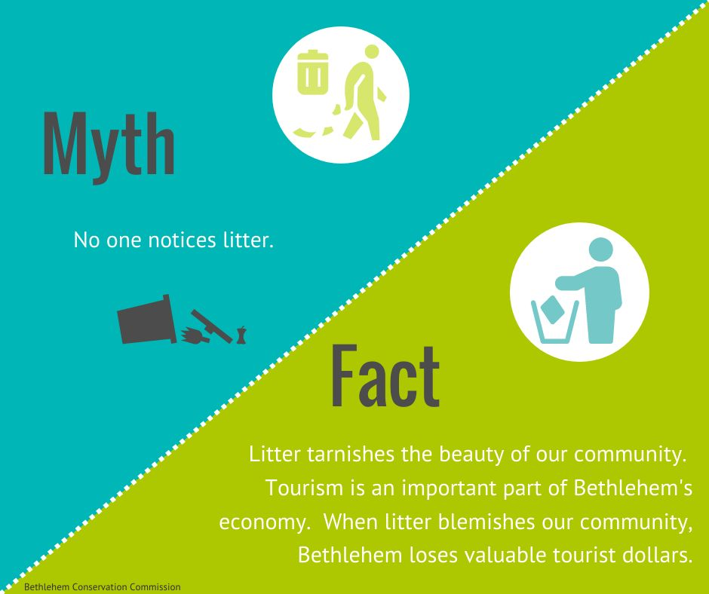
April 1, 2022 – Mark your calendars: May **, 2022 is Bethlehem Roadside Clean-up Day. Meet at the Gazebo between 10:00- 10:30 for road assignments and trash bags.
(Image: Roadside Cleanup Flyer)
May 1, 2022 - Thank you for helping keep Bethlehem beautiful!
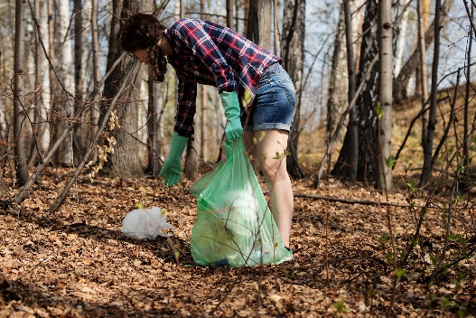
June 1, 2022 – Tip from your neighbor: “When I bring my dog out for a walk, I bring a small trash bag to pick up any trash I see along the way.” Do you have a good tip?
July 1, 2022 - Heading to the coast this summer? Did you know an estimated eight million tons of trash from land makes it way to the ocean each year? Here are a few tips from the USFWS: Buy fresh and local. Avoid excess packaging. Use reusable cloth bags instead of plastic bags. Dispose of waste responsibly. Reduce. Reuse. Recycle. https://www.fws.gov/refuges/features/OceansOfTrash.html
August 1, 2022 – Did you know that litter is harmful to pets, wild animals, and farm animals? Please keep our town litter-free.
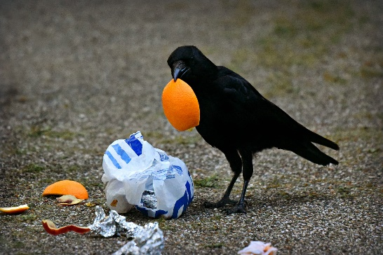
September 1, 2022 – Do you help clean up litter in town? Here are some interesting facts about littering. https://litteritcostsyou.org/9-interesting-facts-and-statistics-about-littering/
October 1, 2022 - Tip from your neighbor: “The scouts taught me to leave a place better than you found it. Picking up extra trash at your campsite or on your next hiking trip is easy to do.”
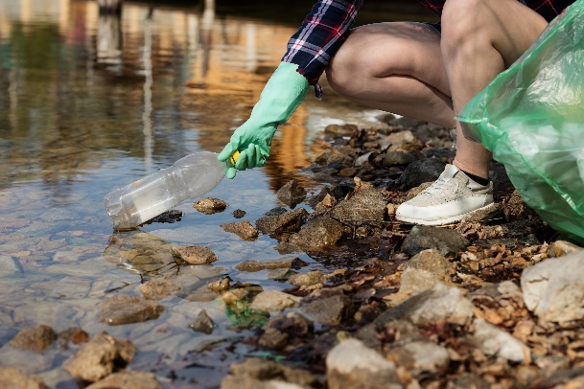
November 1, 2022 – Leaves are down – it’s the perfect time to pick up some roadside trash that has been hiding.
(need pic)
December 1, 2022 – Did you know that you can adopt a road and commit to keeping your stretch clean year round? Learn more about it here:
January 1, 2023 – Happy New Year from the Bethlehem Conservation Commission! Our resolution is to live in a beautiful town with no litter! Will you join us in our pledge to make Bethlehem beautiful?

------------------------------------------------------------------------------------------------------------------------------
Myth and facts at bottom of this webpage: https://www.penndot.gov/about-us/RoadsideBeautification/LitterFacts/Pages/Litter-Facts-and-Myths.aspx

