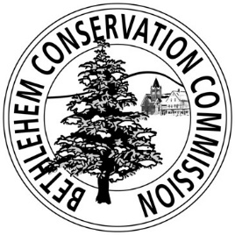
Town Forest Event Liability Form and Proof of Insurance

This form is to be completed by organizations holding Commission approved events on the Bethlehem Town Forest. The Organization named below must renew this form on an annual basis, or update it if insurance coverage has changed.
The Organization agrees that it will carry any and all insurance which will protect it and the Bethlehem Conservation Commission from any and all claims and demands including but not limited to any and all claims for personal injury and/or death, and property damages which may, in any way, arise from or out of the event the Organization is conducting on the Bethlehem Town Forest, Bethlehem, NH.
Prior to the event, the Organization shall demonstrate that it carries a general liability policy with limits of $1,000,000 per occurrence and $2,000,000 aggregate.

Name of Organization:__________________________________________________________________
Contact Name: ________________________________________________________________________
Phone:_______________________________________________________________________________
Email: _______________________________________________________________________________
Address: _____________________________________________________________________________

Today’s Date:______________________

Organization Signature: _________________________________________________________________

Bethlehem Conservation Commission Signature: _____________________________________________

